
  Haut du formulaire
  
  Bas du formulaire

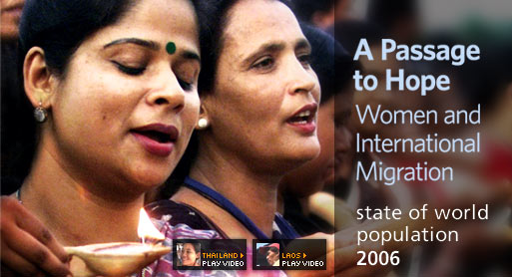


Go to Report online

Press Kit & Other Resources

Multimedia Presentation

Ordering Information

Previous Year´s Reports



 | 
   |  | 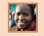 | 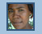 |  |  |  |  | 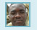 | 
  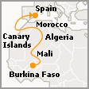 |   BURKINAN, IMMIGRANT IN SPAIN  Adama’s migration journey took him from Burkina Faso through Mali, Algeria and Morocco to Spain – first to the Canary Islands and later to the Spanish mainland. The total journey took Adama over 3 years.  Read full story

| Contact Us | Help/FAQs | Site Index | Other UN Sites | Terms & Conditions | Fraud - Hotline |

